**Textbook List Instructions**

**Using the Spreadsheet**

As you search for books from the printed list, please fill out the Willis Textbook List spreadsheet. Each shift that you work on the list, begin from the blank template and email me your work when you finish for the day.

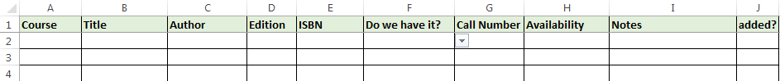

1. Course: Enter the full course number.

Example: BIOL 4560

1. Title: Enter the full title of the book. The textbook list abbreviates many of the titles, so you can **find the full title by searching the ISBN in WorldCat and copying it from there**.

Example: On printed list: “INSTRUCTIONAL ASSESS. OF ENG…IN K-”

Enter as: “Instructional assessment of English language learners in the K-8 classroom”

1. Author: Enter the author name that appears on the printed list.

Example: Brantley

1. Edition: Enter the edition and year.

Example: 4th 10

1. ISBN: Enter the full ISBN.

Example: 978-0-471-67600-3

1. Do we have it?: Choose the most appropriate option from the drop-down list. Do not include instructor-owned copies (GRW, ECR, etc.).

Yes – The Libraries own a copy of the same or newer edition.

No – The Libraries do not own a copy.

Older ed. – The Libraries own a copy of an older edition.

E-book – The Libraries own an e-book copy of the same or newer edition.

E-book older ed. – The Libraries own an e-book copy of an older edition.

1. Call Number: If the Libraries own a copy, enter the call number. If we have more than one edition, choose the most current edition.

Example: UF503 .J65 1998

1. Availability: Choose the most appropriate option from the drop-down list.

Available – The book is currently showing as available in the catalog.

Checked Out – The book is currently checked out to a patron.

On Search – The book is showing as on search in the catalog.

Missing – The book is showing as missing in the catalog.

Long Overdue – The book is checked out and was due in a previous semester.

Preservation – The book is currently in preservation.

Other – Use if no other option is appropriate. Use the notes field to provide more information.

1. Notes: Include notes with additional relevant information when necessary. Can be used to address additional copies/editions, unusual locations (Rare Books, UNT Dallas, etc), or any other information you deem important.

Example: On reserve at Eagle Commons

1. Added?: Please leave this field empty.

**Using the Printed List**

This is how textbooks for a course appear on the printed list:

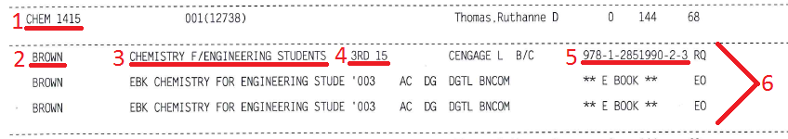

1. Course number
2. Author
3. Title
4. Edition/Year
5. ISBN
6. The information for each textbook for a course is listed on a separate line beneath the course information.

Books used in more than one section or course

Multiple sections of the same course may use some or all of the same books. For each course, only one entry for each book is needed in the spreadsheet. In the example below, there are three sections of AEAH 4813 but two of the sections use the same books. This course would need four entries in the textbook list spreadsheet, one for each unique book.

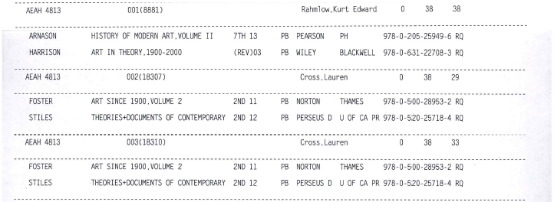

In some cases, the same book will be used in more than one course. Please list the book in the spreadsheet for each course that uses it.

Print and e-book copies for the same class

In the following example, all three books listed for the course are the same. The first is the print version and the other two are e-book versions. In this situation, use the information for the print version in the spreadsheet.

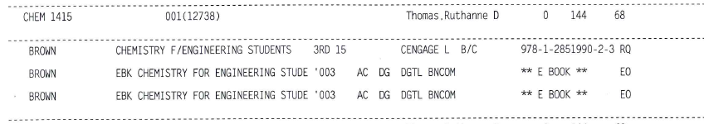

Equipment and other special materials

Some classes require special equipment such as safety goggles. These items do not need to be included in the spreadsheet.

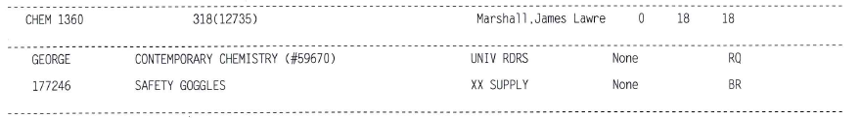

**Tips for Searching for Books**

-When determining whether the Libraries own a copy of the book, it is a good idea to search both WorldCat and the Libraries’ catalog.

-If WorldCat links to an older edition of the book in the Libraries’ catalog, try doing a title or author search in our catalog to see if a more current edition is available.

-If the title of a book is in a foreign language and a title search in our catalog does not have results, try searching again leaving off the initial article (el, la, un, etc.), if applicable.

-When there are several copies of a book, some copies will not be displayed on the main catalog record. Click on “View more copies…” to check for available copies.

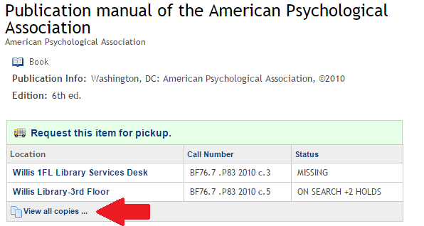

**Requesting books from Sierra**

-Unfortunately, when placing holds through Sierra at Willis, items requested from Willis do not appear in our Item paging list.